**Trading Skills: How to Predict and Calculate the Next Candlestick**

The Japanese have been using candlestick charts many years before the western world created bar charts of any sort. Today, these candlestick patterns have become a crucial tool for traders to predict potential price movements of various assets. In fact, the most popular advanced trading platforms include these charts in their list of essential technical analysis tools.

**What are Candlestick Charts in Trading?**

These are a powerful technical tool because they can display data from across several timeframes in a single price bar. The patterns created by these bars over time can help traders identify key support and resistance levels and make informed predictions about the potential direction of future price movements.

A candlestick is made up of a body, which represents the price range of the chosen asset from the open to the close of a trading timeframe, while the wick or shadow above and below the body represents the high and low price, respectively. The colour of the body is also important since it indicates the potential market direction.

– An empty (white or green) body indicates price rise  
– A full (black or red) body indicates a price decline

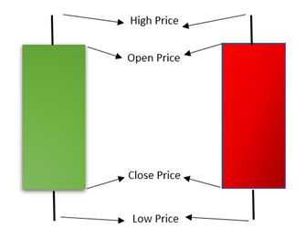

There are numerous patterns that can be created with candlesticks, based on which market conditions can be better understood and trading opportunities identified. The main purpose of checking these patterns is to attempt to predict where the next candlestick might form and, therefore, whether we are looking at a bullish trend, bearish trend or continuation of the price level. Here’s a look at some patterns and how they can be used to estimate the next price move.

**Predicting a Bullish Market**

Bullish candlestick patterns could signal a reversal from a downtrend to an uptrend. In general, they are used for traders to make informed decisions about entering into a long position. Here’s a look at some of these patterns:

**1. Bullish Engulfing Pattern**

This pattern usually forms when buyers outnumber sellers in the market. It consists of two candlesticks, where the one with the longer green (or white) body engulfs another with a smaller red (or black) body.

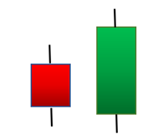

**2. Hammer**

This pattern consists of a small body and a long lower wick. It usually forms at the low end of a downtrend. It indicates that while there has been selling pressure during the trading timeframe, buyers are now driving the price up. This usually signals that the next candlestick could be a green one.



**3. Inverted Hammer**

This is similar to the previous pattern, except that the upper wick is the one that is long. It is taken to indicate that although there has been buying pressure, sellers did try to take over but failed to drive the price down. So, buyers are likely to rule the market again soon.

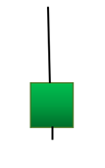

**Predicting a Bearish Market**

Bearish candlestick patterns, contrary to their bullish counterparts, signal a reversal from an uptrend to a downtrend. They can be used to identify resistance levels and are usually taken as a signal to enter a short position. Here’s a look at some of these patterns:

**1. Bearish Engulfing Pattern**

This pattern usually forms towards the end of an upward trend, where a short green candle is followed and engulfed by a long red bodied candle. It is taken to indicate a slowing in price movement and a potential downturn in the market. The lower the engulfing candle, the more likely the impending downward trend.

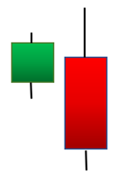

**2. Shooting Star**

Similar in shape to the inverted hammer, this pattern is usually formed during an uptrend. It has a long upper wick with a small body. The pattern occurs when the close price is only a little higher than the open price, although the price rallied through the session. It almost looks like a shooting star falling down to the Earth.

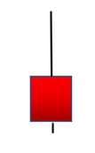

**3. Hanging Man**

This is the hammer of the bearish market, except it follows an uptrend and signals the onset of a downturn. It is taken to indicate that while there was major selling pressure during the session, buyers were able to drive up the price. However, the bears took control of the market from the bulls.

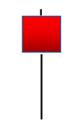

**Predicting Trend Continuation**

There also are candlestick patterns that indicate that there is unlikely to be any change in the price direction. It could be a period when there is no significant change in price or a time of indecision in the market.

**1. Spinning Top**

Just like a top, this candlestick has a small body at the center of an upper and a lower wick of the same length. It reflects that there is no significant change in price, with both buyers and sellers putting almost equal pressure on the price. Traders often consider this pattern as an indicator of a consolidation or rest period in the market, usually after a meaningful downtrend or uptrend.

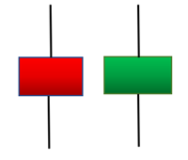

**2. Doji**

Here, the opening and closing price of an asset are almost at the same level, so the candlestick resembles a plus sign or a cross. The body is almost negligible, while the wicks could be of varying sizes. Traders consider this pattern as an indicator of an ongoing struggle between the bulls and bears in the market, with no clear winner. Taken alone, the Doji is a neutral indicator. However, it can be formed during reversal patterns too.

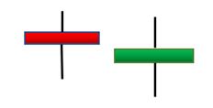

While candlestick patterns can offer useful information regarding potential price moves, they work better for longer timeframes. It is a good idea to first try them out on a demo account. This can help you become familiar with all the features of your advanced trading platform, while also honing your skills in reading charts and patterns.